Beschreibt, was ihr über den Ozobot herausgefunden habt:
Der Ozobot kann...
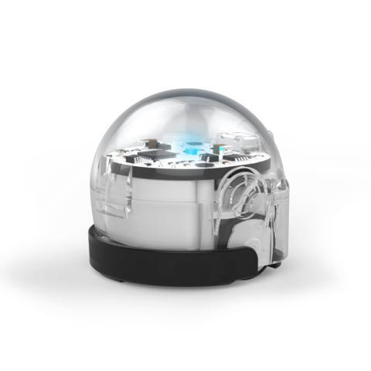
_____________________________________________________________
"Dieses Foto" von Unbekannter Autor ist lizenziert gemäß CC BY-NC-ND
_____________________________________________________________
_____________________________________________________________
_____________________________________________________________
_____________________________________________________________
Wie macht er das?
_______________________________________________________________________________________________
_______________________________________________________________________________________________
_______________________________________________________________________________________________
_______________________________________________________________________________________________
Warum macht er das?
_______________________________________________________________________________________________
_______________________________________________________________________________________________
_______________________________________________________________________________________________
_______________________________________________________________________________________________
_______________________________________________________________________________________________
_______________________________________________________________________________________________
Mit dem Ozobot gab es Probleme...
_______________________________________________________________________________________________
_______________________________________________________________________________________________
_______________________________________________________________________________________________

